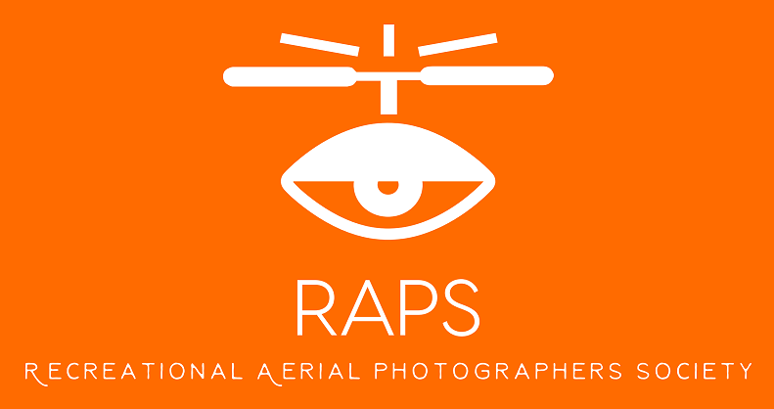
RECREATIONAL AERIAL PHOTOGRAPHY SOCIETY. (inc no. 1A41191)

Member Application Form – 2017/2018
Applicant Information
Surname: Given Names: Preferred Name:
For Name Badge, Correspondence, etc.
Address: Suburb: Post Code:
Date of Birth: / / Email Address:
Phone (H): .......... Phone (M):.................................. ..............................................
MAAA Information IF CURRENT MEMBER (www.maaa.asn.au)
AUS Number: Current Club & Year MAAA License held:
If you hold a current MAAA license, enter your AUS number, Club, and year. Membership of QTF does not replace membership with a MAAA Affiliated club.
Type of use | Multi-rotor |  |  | Fixed wing
Recreational
Club Information
Membership Type  (Tick one) |  | Full Member  (Full Year) |  | RAPS Renewal and Membership #
General Membership |  | $110.00 |  | RAPS Member #..........................
Membership Fees must be paid to the qtf association treasurer:
Payment may be made by one of the following methods (tick one):
Payment Method.  Electronic Funds Transfer |  |  | Postal Address.  The Treasurer,  MAAQ  P.O. Box 1057,  Mudgeeraba, QLD 4213  (Please do not post cash) | Electronic Funds Transfer  Post a copy of the EFT transaction with your completed Application Form as proof of payment.  QTF Account: BSB: 014-536 Acct#: 285135127  - Please include your MAAA AUS number and first three letters of your Surname in the EFT transaction text (e.g. 41557DOD) for continuing member.  - For new members full surname.
Declaration
MAAA Insurance Cover – Your obligations as a Financial Member
As a financial member of the Recreational Aerial Photography Society (RAPS), which is affiliated with the Model Aeronautical Association of Queensland Inc. (MAAQ) and the Model Aeronautical Association of Australian Inc. (MAAA), you undertake to abide by the terms of the MAAA insurance policy and the general RAPS rules (MAAA MOPS) and by-laws for the flying and operation of your models. All insurance aspects, claims, investigations and communication is to be with the Model Aeronautical Association of Australia (MAAA) and your affiliated club (RAPS).

Your membership with this club constitutes a membership with the MAAQ/MAAA. You are to remain a full financial member of this affiliated MAAQ/MAAA club and for your insurance obligations to be fulfilled.
I agree to comply with the Rules and By-Laws (and MOP’s), and subsequent variations as may be promulgated from time to time of the Recreational Aerial Photography Society (this club) to maintain my MAAA membership. I also agree that the following mandatory questionnaire has been completed by …………………………… (name) and acknowledge that I will not contrary to the MAAA MOP’s and CASR 101.

Applicant’s Signature:…………………………………………………………..Date: /……………/…………….
OFFICE USE ONLY EFT …………………. Cheque # …………….. Receipt #.................
Date Received………/………/……… Date membership issued………/………/………

RECREATIONAL AERIAL PHOTOGRAPHY SOCIETY (RAPS) – OPERATIONS QUESTIONAIRE – MANDATORY

Question | Answer
- How high can I fly my drone to get that perfect photograph?

- How close can I fly to other people, buildings and/or vehicles etc?

- Can you fly through cloud or fog?

- Can you fly at night as a RAPS club member?

- Can you fly over heavily populous areas such as beaches, parks and sporting venues?

- Can you fly in restricted airspace such as military installations, Sydney harbour, air shows or other large public events?

- What is the maximum weight of a recreational drone?

- How far should you keep away from airfields, aerodromes and helicopter landing site’s.

- Where can I fly??

- Do I need to respect other people’s privacy?

- If I see other aircraft nearby what should I do?

